


Description of Datapower
IssueS with IMSConnect

backend static IMSConnect
Transactis – SOA Appliance IDGx2

Updates
Référence | Titre | Révision
[0] | Initial improvement request | V0.0 | 05/02/2020
 | Response from IBM | V1.0 | 17th February 2020

Summary
Summary 3
I. Use of IMSConnect as a Backend 4
1) Description of the need 4
1.1 IBM description of the implementation 4
2.1 The multi-protocol gateway scenario 4
2) Description of the issue 5
The IMS protocol requirements: 5
Official IMS Communication and Connection document from IBM 5
Our observations: 6
II. WORKAROUND 7
1) Description of the IMS Connect configuration setup as a Default Backend URL 8
2) MULTI-PROTOCOL GATEWAY to convert TRANSACTION CODE in ASCII to EBCDIC 10
3) Conversion of EBCDIC TRANSACTION CODE in BASE64 11
4) Concatenation of BASE64(transactioncode) with BASE64(Data flow) 11
III. RFE opened : 140261 12

I. Use of IMSConnect as a Backend

Description of the need

A source is handled by the FrontSide handler (it can be HTTP(s) or MQ or IMSCALL) and the static backend of the multi-protocol gateway is pushing flow to an IMS instance thru an defined IMSConnect.
Also, it waits for a response, before replying to the source.

IBM description of the implementation

Use of dpims:// providing the name of the predefined IMS Connect at the Default BackEnd URL.

The multi-protocol gateway scenario
Out Queue
Stack IP
ioarea
XCF
IMS
IMSConnect
transaction
Front Get
Front Side handler
Processing policy
static backend IMS
Front Put
In Queue
service
Datapower idgx2
ZOS

TCP/IP

The front application is expecting a response from an IMS Service.

Note: in order to ease the technical comprehension of this scenario, Datastore, userId, and so on... are not mentioned.

Description of the issue

The IMS protocol requirements:

- to setup a Header frame made of 80 bytes that corresponds to the HWSSMPL0 ( alias *IRMREQ* ) as exit identifier
- to setup 4 bytes corresponding to LL and ZZ, where LL is the length of each block (limited to 32Kb each) and ZZ ( reserved for IMS )
- To setup a Transaction code made of 8 bytes written in EBCDIC or ASCII encoding that corresponds to the transaction triggered on IMS
- Then the rest of the flow corresponding to the Data.

Official IMS Communication and Connection document from IBM

ftp://public.dhe.ibm.com/software/IMS/documentation/ims15pdfs/IMS_15_Communications_and_Connections.pdf

- HWSSMPL0 structure: see page 209.

- The TRANSACTION ID value: see page 351

An IMS client application can send the IMS transaction code as ASCII, EBCDIC, or Unicode. When the IMS
client application sends the transaction code as Unicode, the IMS Connect user message exit (HWSSMPL0
and HWSSMPL1) translates the transaction code from Unicode TO EBCDIC. When the client application
sends the transaction code as ASCII and the remaining data as Unicode, only the transaction code is
translated to EBCDIC. A valid 8-byte IMS transaction code can be constructed from the following
characters and must begin with an alphabetic character:
• A through Z (uppercase only)
• 0 through 9
• Special characters #, $, @

Our observations:

The EBCDIC Header conversion is setup to : ON
- Header frame HWSSMPL0 ( alias *IRMREQ* ): correctly setup by the appliance
- LL and ZZ values: correctly setup by the appliance
- Transaction code not setup by default by the appliance
- Rest of flow’s encoding depends on Transaction code manually added at the beginning of our data flow using a stylesheet (xslt)

A ) if Transaction code is written in ASCII, then TRANSACTIONCODEandDATA will remain unchanged (it is to say in UTF8). IMS will detect an error when reading transaction code which is not in Ebcdic.
DFS064 15:08:59 DESTINATION CAN NOT BE FOUND OR CREATED, DEST=XXXX

B ) If Transaction code is written in EBCDIC(…), the flow content beyond the transaction code remains unchanged. (compliant with section page 351).

The EBCDIC Header conversion is setup to : OFF
- Header frame HWSSMPL0 ( alias *IRMREQ* ): correctly setup by the appliance
- LL and ZZ values: correctly setup by the appliance
- Transaction code not setup by default by the appliance
- Rest of flow’s encoding depends on Transaction code manually added at the beginning of our data flow using a stylesheet (xslt)
A ) the Transaction code written in ASCII will lead the appliance’s IMS Connect to have all the flow content converted to EBCDIC even if it has been sent in UTF8. (not restricted to transaction code as described in with section on page 351)
Our main impact is that the message translation will lose some UTF8 special characters and replaced by substitute character 0x3F due to the restricted conversion table EBCDIC1047 of IMSConnect on ZOS side.
Also as received in EBCDIC, the IMS Program must Re-convert flows in UTF8 (as far as it can).

II. WORKAROUND

it exists a mismatch between the official documentation regarding message translation section (page 351) and conversion from an IMSConnect defined on an appliance.

We decided to go on with EBCDIC header conversion to ON.

We developed a specific xslt for adding an IMS transaction code (previously converted into EBCDIC).

Note:
The use of DPA (built using Websphere Transformation Extender = WTX, now ITX v9.x and v10.x) has been withdrawn because it imposes to be compliant with Clause Copy, which is not the case if XML flows needs to be sent to IMS.
The XML message may have variable size which is not compliant with hard-coded length in ClauseCopy.
For sure, most of messages are in XML format.

Description of the IMS Connect configuration setup as a Default Backend URL

Use of IMS Connect wizard.
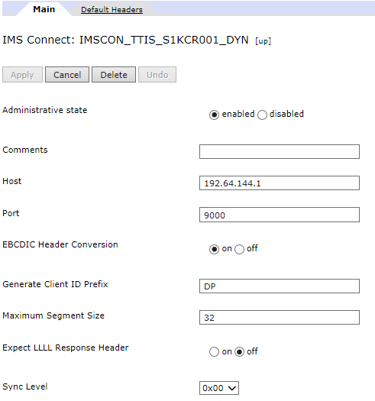

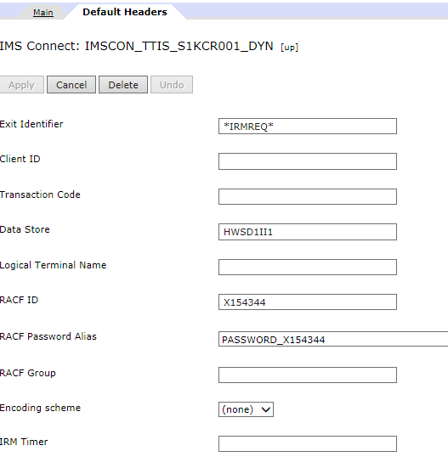

MULTI-PROTOCOL GATEWAY to convert TRANSACTION CODE in ASCII to EBCDIC

Conversion of EBCDIC TRANSACTION CODE in BASE64

See attached

Concatenation of BASE64(transactioncode) with BASE64(Data flow)

See previously attached MPG_IPCE_CRE_SG.zip

The output message for IMS : where transaction code (here S1KCR002) has been converted to EBCDIC (hexa value e2 f1 d2 c3 d9 f0 f0 f2).

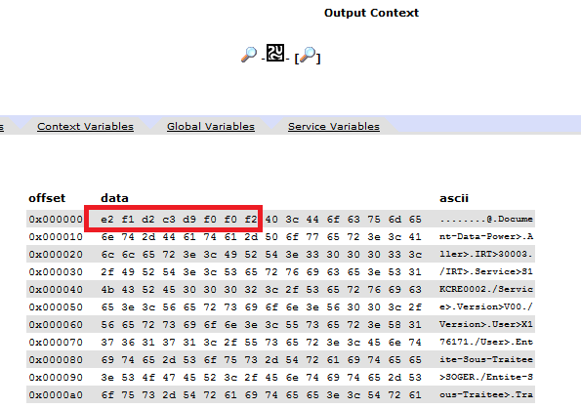

III. RFE opened : 140261

http://www.ibm.com/developerworks/rfe/execute?use_case=viewRfe&CR_ID=140261

