



**DATAPOWER**

**LOAD BALANCER GROUP ENHANCEMENT REQUEST**

**Transactis – Datapower 2018.4.1.16**

|  |  |  |  |
| --- | --- | --- | --- |
| **Updates** | | | |
| **Référence** | **Titre** | **Révision** | |
| [0] | Initial improvement request | V0.0 | 09/04/2021 |
|  |  |  |  |

Summary

Summary 3

I. Description of load balancer group ‘s need 4

a. Configuration of the LBG object: 4

b. Our target 5

I. Description of load balancer group ‘s need

We need to access multiple webservices defined on a Load Balancer group object. ( tab members )

These remote webservices can be accessible on different https ports.

We would like to be able to monitor any of these distant Urls using the Health functionality (health tab),

Type TCP Connection.

* 1. Configuration of the LBG object:

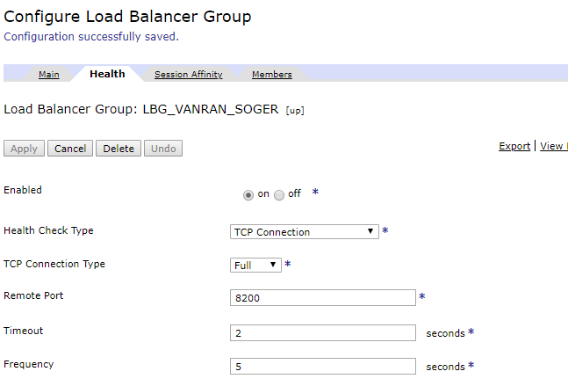

* 1. Our target

Our suggestion is to define an arbitrary Remote Port on Health tab, for example here 8200, that will be the Entry Mapped Port for any of the member(s) whose health Port corresponds to 8200.

The target is to have a monitoring engine that detects any defects on remote Urls side and provides alerts.

