# Testable API Call within Developer Portal

## Pre-Requisites

1. Configure an 3rd party OIDC provider and enter the username / password (Client ID / Client Secret from the configured application within the OIDC provider) as following  
     
   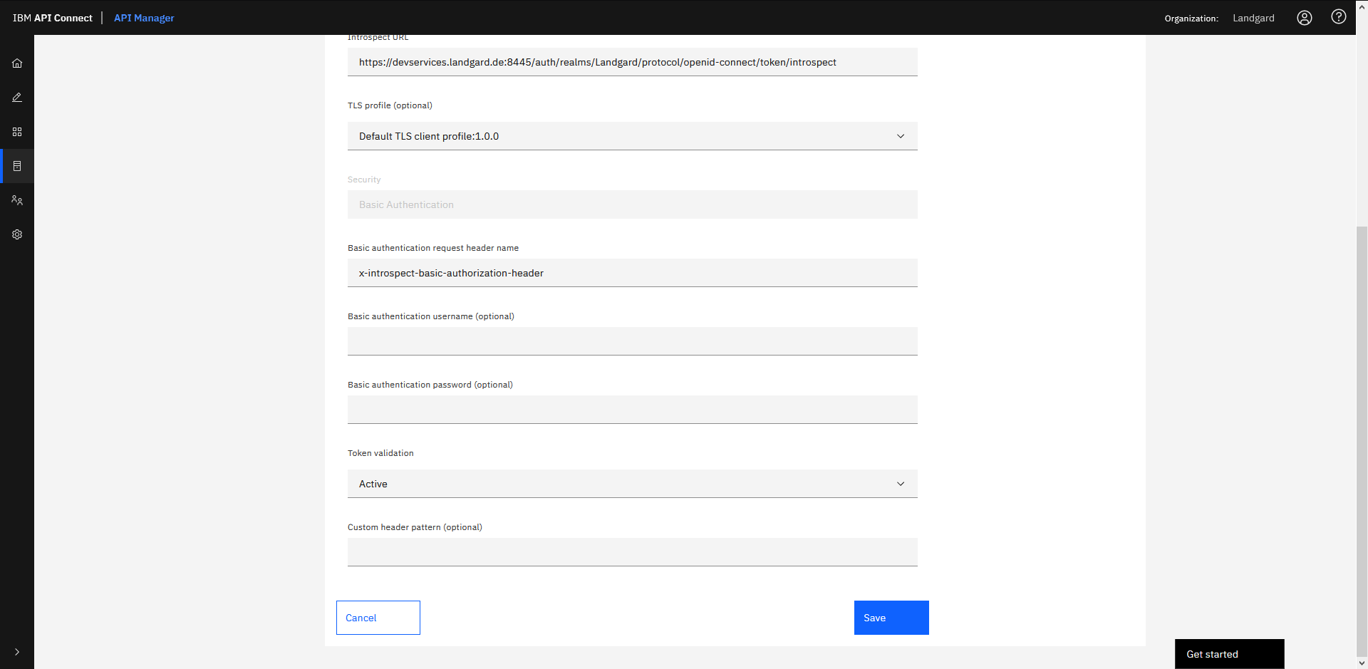  
     
   That’s currently not possible and will be solved with the  
   APAR 73697 - 500 API ERROR ACCESSING THE OAUTH PROVIDERS PAGE WHEN BASIC AUTHENTICATION PASSWORD IS USED IN THIRD PARTY OAUTH PROVIDER
2. Configure the API with the appropriate settings to use the OIDC provider  
     
   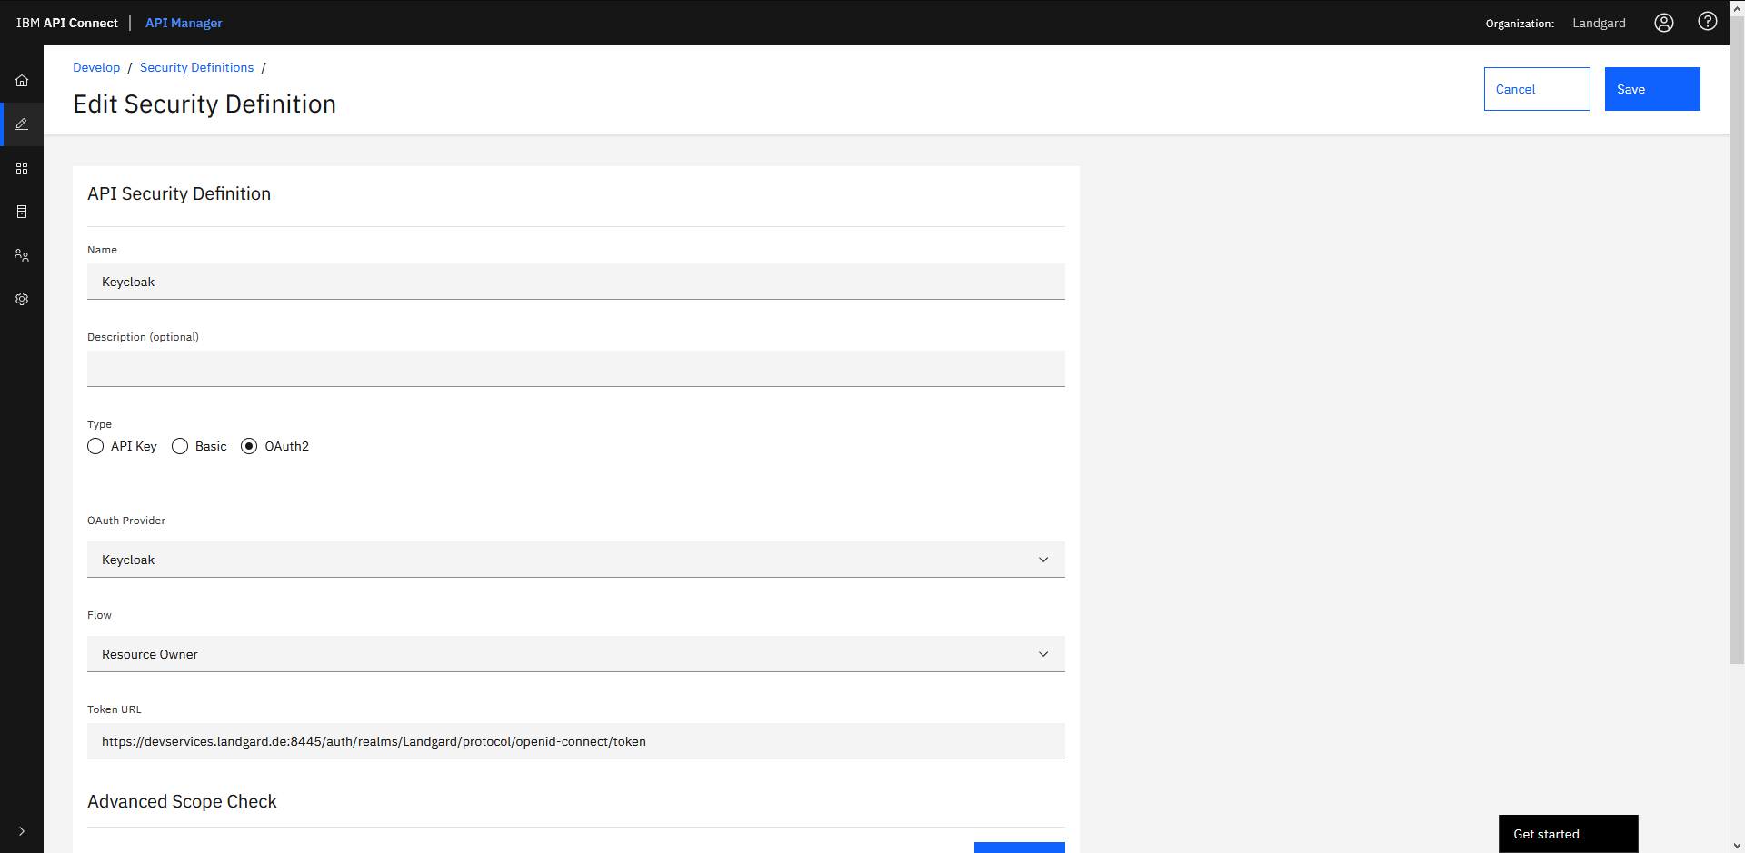  
     
   .. and further settings
3. Publish the API
4. Try the API within Developer Portal, 1st step is the Token Request  
     
   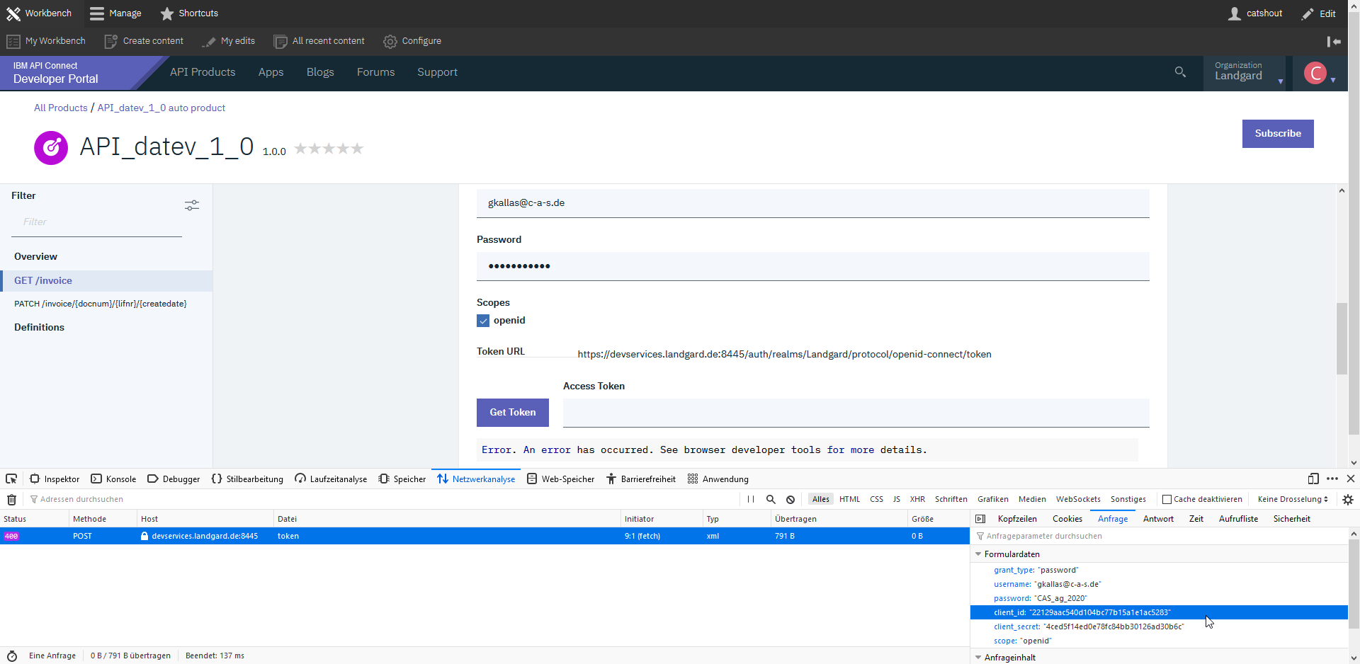

The expectation is, that for the “Get Token” it must be used the Client ID and Client Secret that has been configured in step 1 (an NOT the Client ID and Client Secret from the configured App).