1. Role level changes are logged with no details about permissions affected during activity performed.

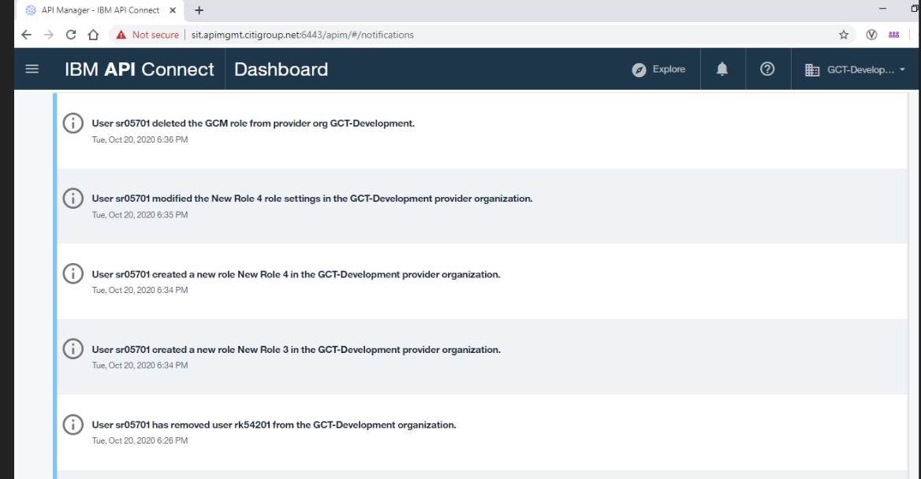

**Expectation:-** when we create new role with permission, it should show the existing and modified permission with respective role. And also it should show the username which role is assign to user.

1. The user modification log events does not contain maker id and are not indicating roles affected by a change. Log is listing all of the roles which remains with profile after the update.

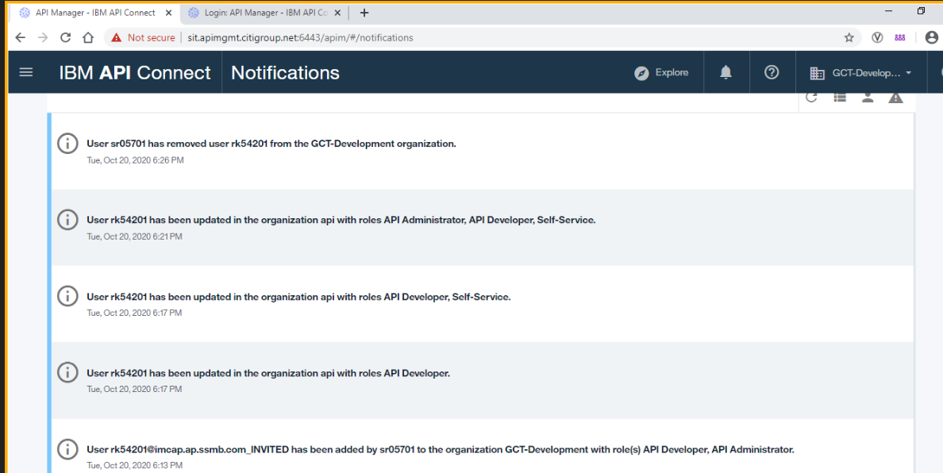

**Expectation:-** Make id is missing who is performing this activity, when maker id allocating roles for the user, its not showing what is the existing roles and current adding role with proper details, as per the above screen shot its showing only modifies roles list.