Issue With Authenticating With More Than One AD Group In WMB

In Message Broker we create a Security Profile to authenticate an account to group in LDAP as configured in the profile. From what I can see only one group can be used for the Security Profile in LDAP group baseDN.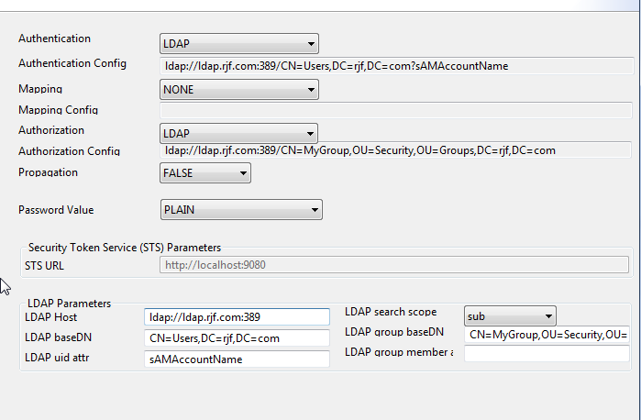

When creating a Soap Input Node the profile is set up to be used.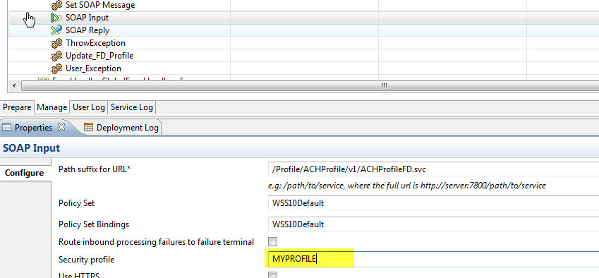

It does not appear that more than one Security Profile can be configured in the node, therefore if only one group can be configured in the profile and only one profile can be used by the input node we are limited to only one group to be configured for authentication in WMB unless we nest other groups in Active Directory to the group being used for the Security Profile.

But in our environment we are discouraged from doing this. So it will be important to have the ability to use more than one group to authenticate against.