**Addendum to RFE 32651 – Static Analysis Tool for ESQL**

For comparison purposes only, the following is a screen capture of the static code analysis results from HP Fortify Audit Workbench for the JCN’s and other Java components within Message Broker for a particular project. Note the categories of coding issues discovered in the left pane, e.g., command injection, dead code, denial of service, etc. Note also in the right pane the summary of total lines of code scanned, total issues found along with a breakdown by weighted score, e.g., High, Medium, Low; and that the certification results for this particular scan pass validation.

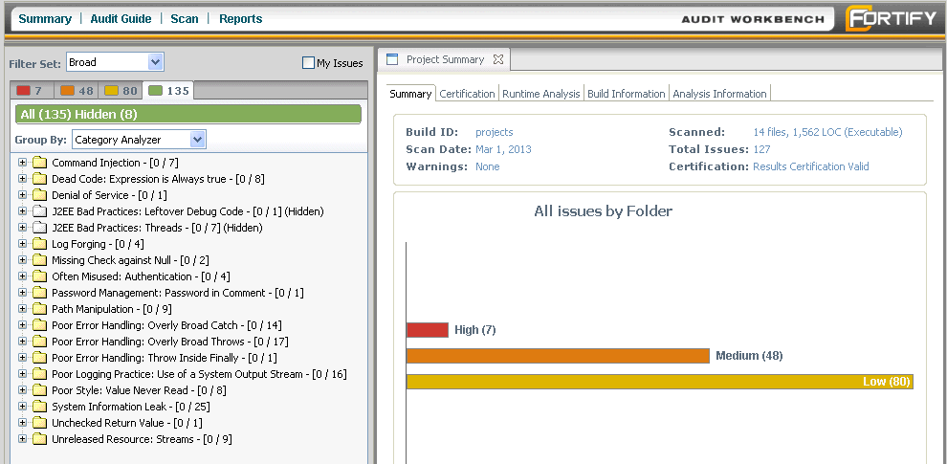

Having this same capability to statically scan ESQL code within Broker and to then provide similar metrics from which a decision can be rendered as to whether the results for any particular scan are valid or not for certification purposes (e.g., code migrations to higher environments) is what this current RFE is all about.

It is a separate question – and one best left for subsequent and custom tailoring – as to what the rulepack needs to be for ESQL code within Message Broker, i.e., it is the set of rules contained in the rulepack for any given source language that determines which categories of code are identified and flagged and weighted as potential issues during the static analysis scan.