# Test Scenario 1: User account is frozen in Salesforce.

Steps to be followed in Salesforce:

1. Navigate to the user that is authorised in and receiving events in setup.
2. Freeze the user.
3. Publish an event in Salesforce.
4. Unfreeze the user.
5. IBM ACE event driven flow should then receive the event that was created whilst they were frozen.

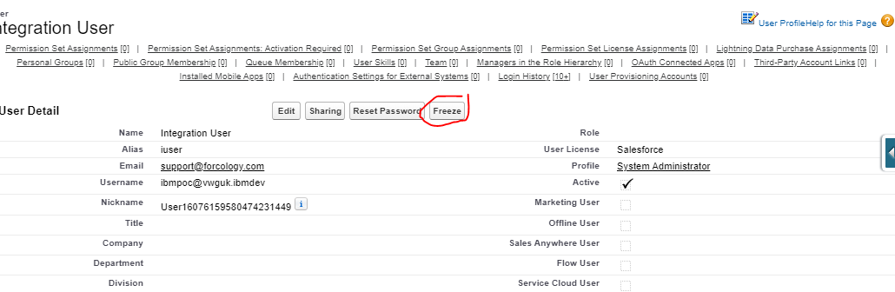

# Current event retention period in salesforce have been set to 72 hours.

Lets say Salesforce team have frozen the user account for 3 hours and unfreeze the account after 3 hours. Could you please let us know whether IBM Event driven flow supports replay functionality in this scenario to retrieve the last 3 hours backlog data or not?

Below is the Event Driven flow which got created in IBM ACE SAAS cloud environment which is currently subscribing Salesforce platform events and this salesforce connector is using authentication mechanism “**Provide a user name and password for App Connect to use (OAuth2) mentioned in below IBM documentation”**

[Connecting to Salesforce from IBM App Connect on IBM Cloud](https://www.ibm.com/support/knowledgecenter/en/SS6KM6/com.ibm.appconnect.dev.doc/how-to-guides-for-apps/salesforce_connect_cloud.html)

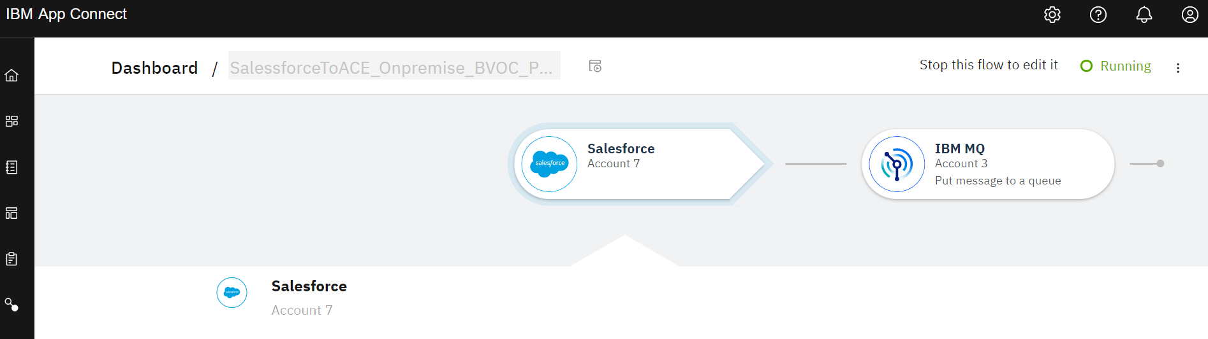

# Test Scenario 2:

# Password/Security token changed have been changed in Salesforce.

1. A password reset is requested for a user.
2. The password is changed, generating a new security token.
3. The OAuth token is revoked (can be done following these instructions) <https://help.salesforce.com/articleView?id=sf.remoteaccess_revoke_token.htm&type=5>
4. An event is published.
5. IBM Event driven flow have to be stopped to update new security token in the event driven flow and start the flow again which re-authorises with the new password/security token.

Will IBM ACE event driven flow capable to retrieve the events created when authorisation is lost and flow is stopped/started again?

If not, will this functionality can be introduced in IBM app connect event driven flow ?

Below is the Event Driven flow which got created in IBM ACE SAAS cloud environment which is currently subscribing Salesforce platform events and this salesforce connector is using authentication mechanism “**Provide a user name and password for App Connect to use (OAuth2) mentioned in below IBM documentation”**

[Connecting to Salesforce from IBM App Connect on IBM Cloud](https://www.ibm.com/support/knowledgecenter/en/SS6KM6/com.ibm.appconnect.dev.doc/how-to-guides-for-apps/salesforce_connect_cloud.html)



Test Scenario 3: is there any option to provide high availability for event driven flows as an active/passive mode?

We got below answer from IBM support team..

“There is no way in app connect to request an active/passive mode but as mentioned above if the active event connector has an issue it will normally be restarted very quickly and all events will be sent. It is important to be aware that we can not guarantee there will never be any duplicate events as there is always scope for duplicate events if a crash did happen and the event connector or the flow got restarted. These duplicates would be the exception but your system still needs to be capable of coping with them if any did occur.”

Could you please let us know the possibility of the occurrence of the crash and occurrence of duplicate events? If there are any duplicate events would it be for last 24 hours or 72 hours as the current salesforce event retention period is 72 hours?