


No POSSIBILTY TO START DOMAIN ONE BY ONE
WHEN QUIESCING ALL DOMAINS.

Transactis – SOA Appliance IDGx2

Updates
Référence | Titre | Révision
[0] | Initial improvement request | V0.0 | 28/07/2021

Summary
Summary 3
I. Quiescing All Applicative Domains ( Domain default ) 4
1) Description of the Issue 4
2) Interactive message for end user 5
3) Suggestion for Enhancement 5
4) Idea suggested to IBM 6

I. Quiescing All Applicative Domains ( Domain default )

Description of the Issue

If you quiesce “all domains”, you can only unquiesce “all domains” again. You can’t individually unquiesce domains.
Same thing applies the other way around.
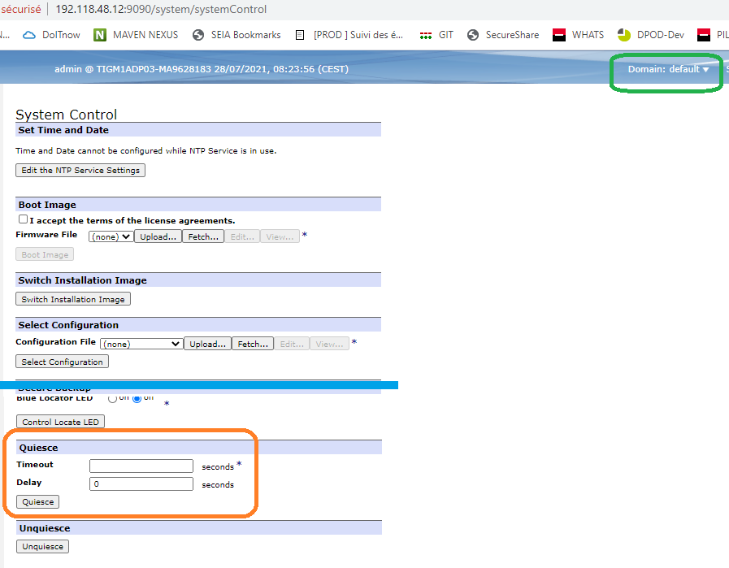

Interactive message for end user

Also from the WebGui interface, there is no error indicating such actions is not possible.
Only on the Blueprint Console, a short message appears but without further explanations.

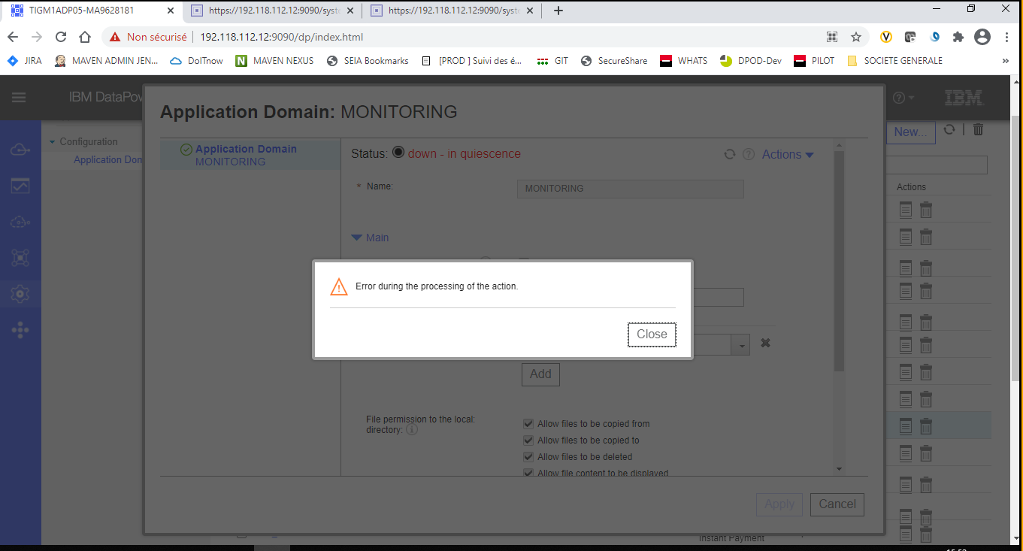

Suggestion for Enhancement

After quiescing all domains, we would prefer or at least have an option to unquiesce each domain for testing purposes and/or to allow traffic back slowly

Idea suggested to IBM

