We setup LDAP on cp-console page.

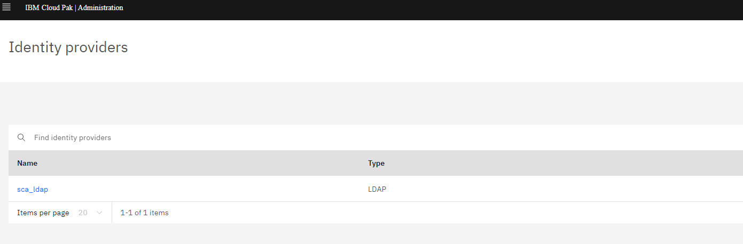

So there is extra Enterprise LDAP authentication type here.


Login the CP4I with LDAP authentication

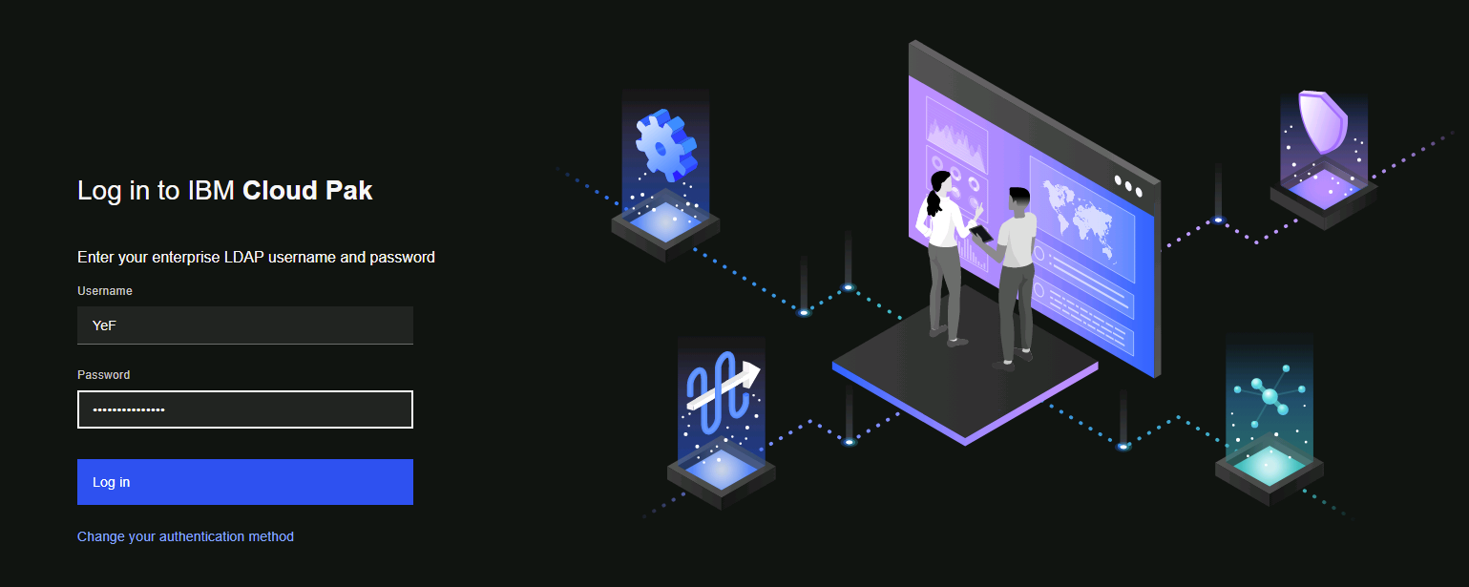

Then access the API Manager, It will re-redirect to API Manager login again. If choosing Common Services User Registry, the user has no permission.

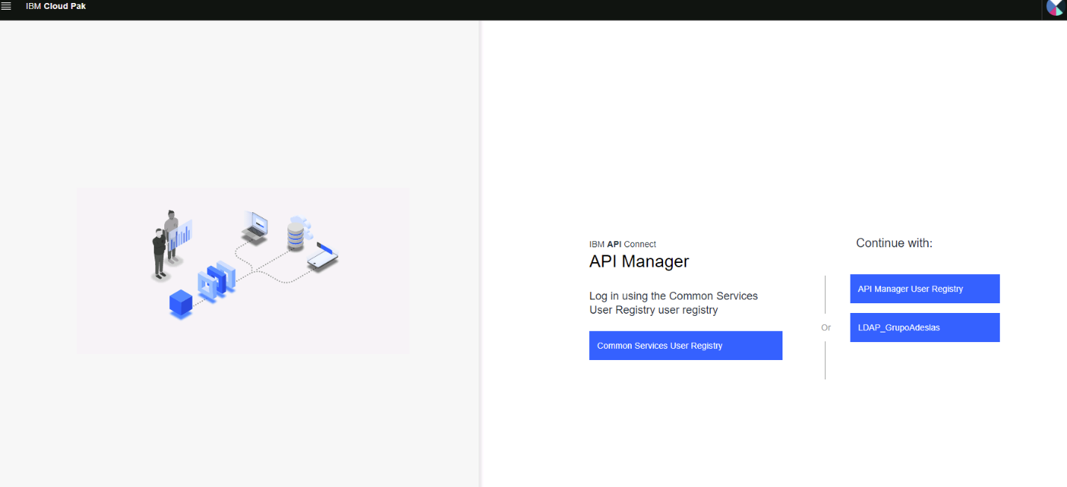

If choosing LDAP_GrupoAdeslas user registry, the user need to input the same username and password again. Then the user has the correct permission.

We checked the member list in API Manager, the members are under the below identity_provider.identity_provider: 'ldapgrupoadeslas'
The customer would like to use one-time authentication. Our idea is that we need to load all member data into the identity_provider: 'common-services' from identity_provider: 'ldapgrupoadeslas'.
Is there any other method to do it? How to do it?

