Create new application in developer portal
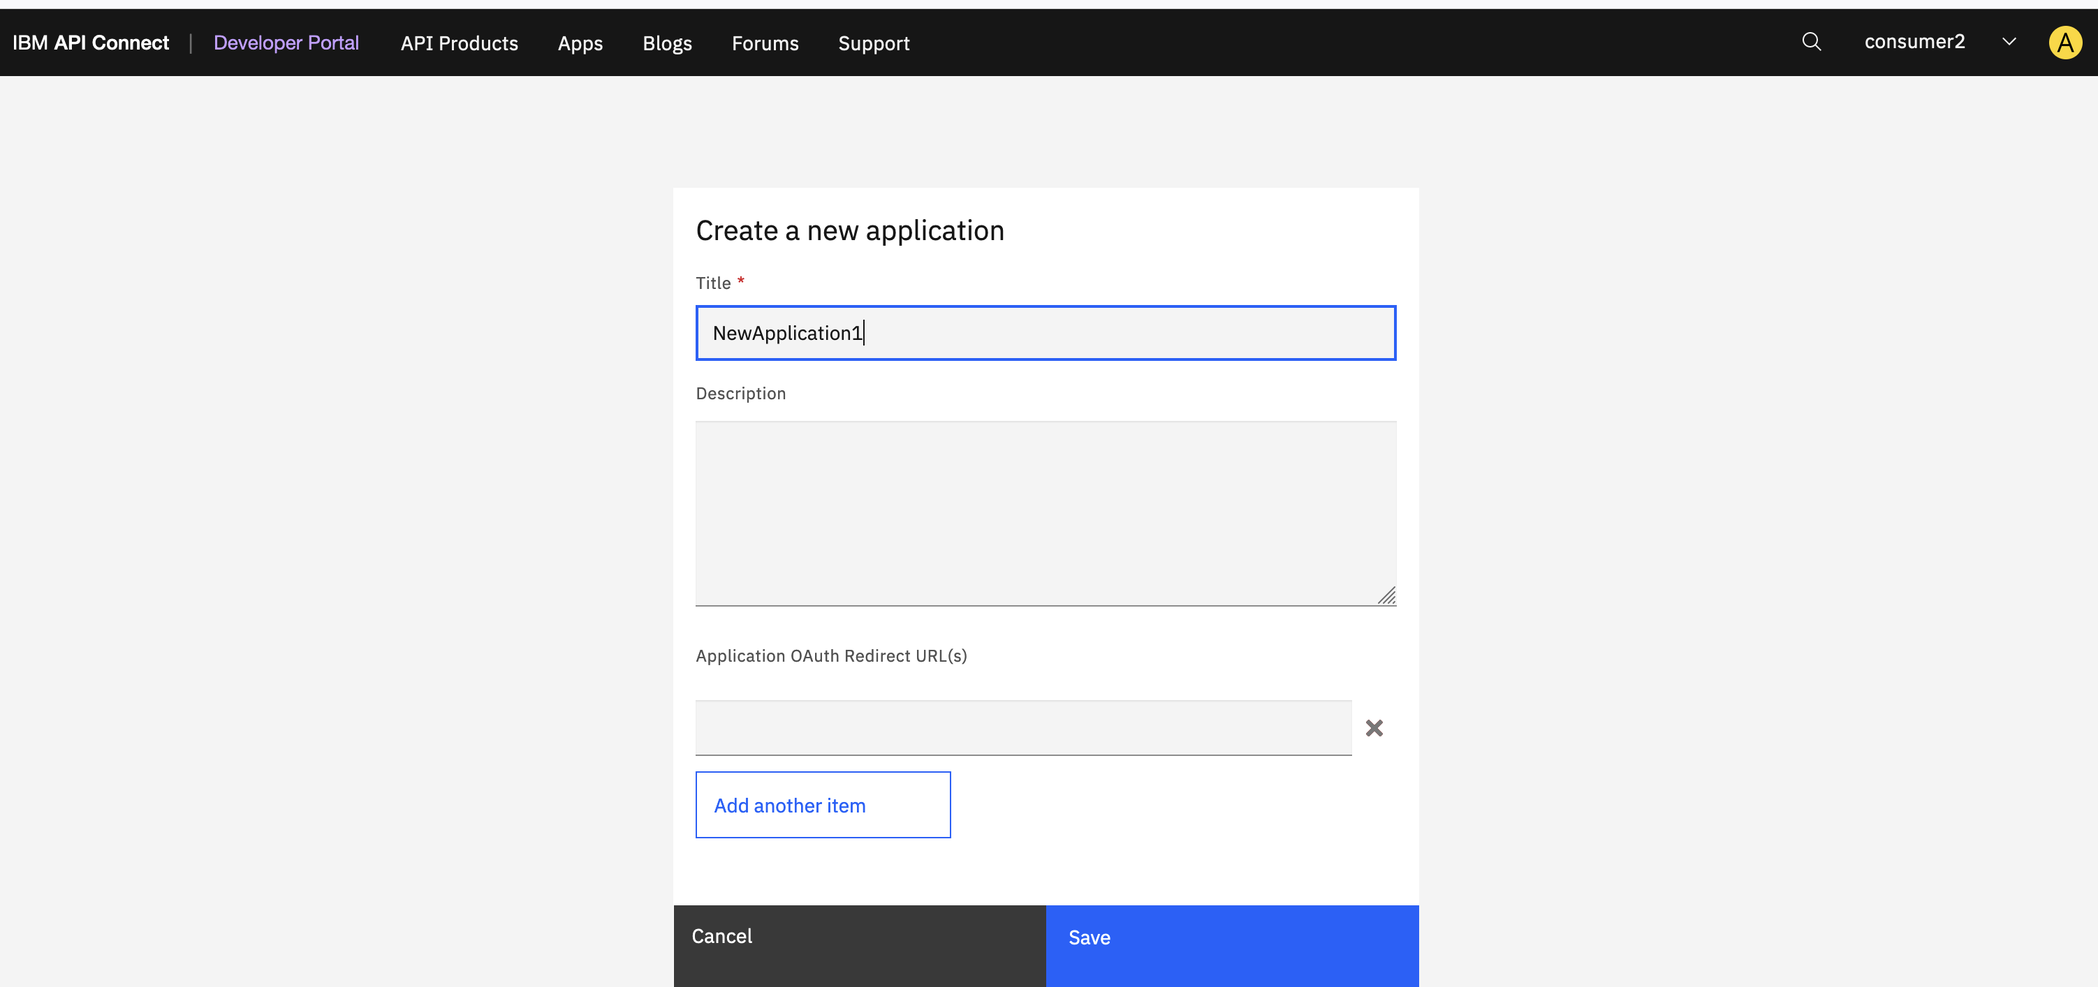
New application is created and key/secret is generated
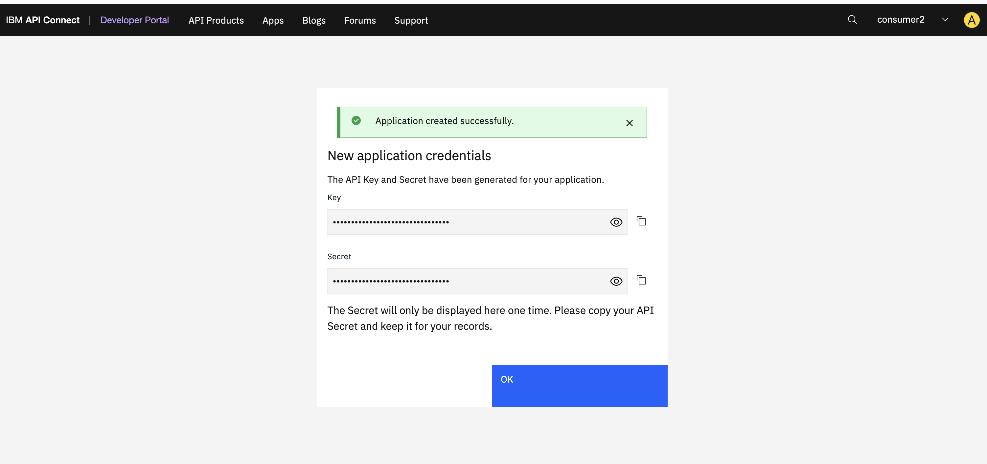
You will see credential under application as below screen. ‘Credential for ….’
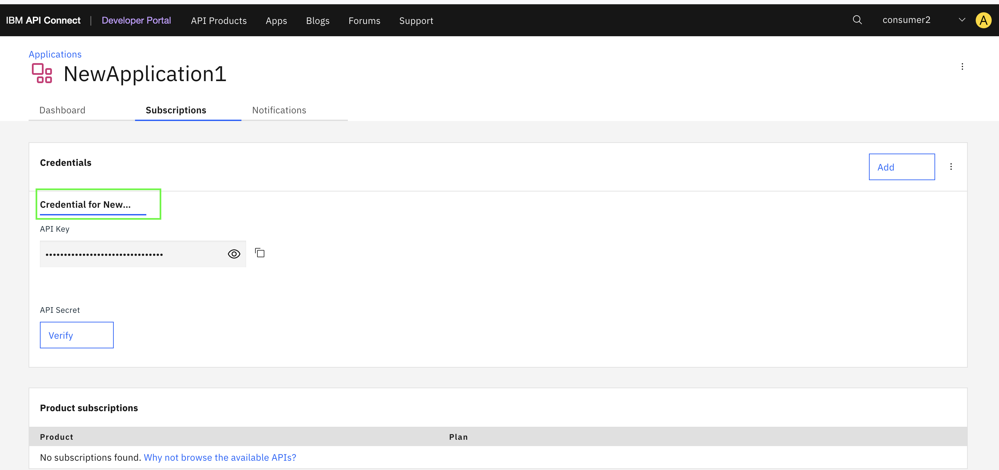
Now got right 3 dots of credential and click edit, you will see edit screen as below and cancel. The summary shows same as Title, but summary does not show on above screen.
Issue : Summary value should be empty or it should be displayed on credential screen above.
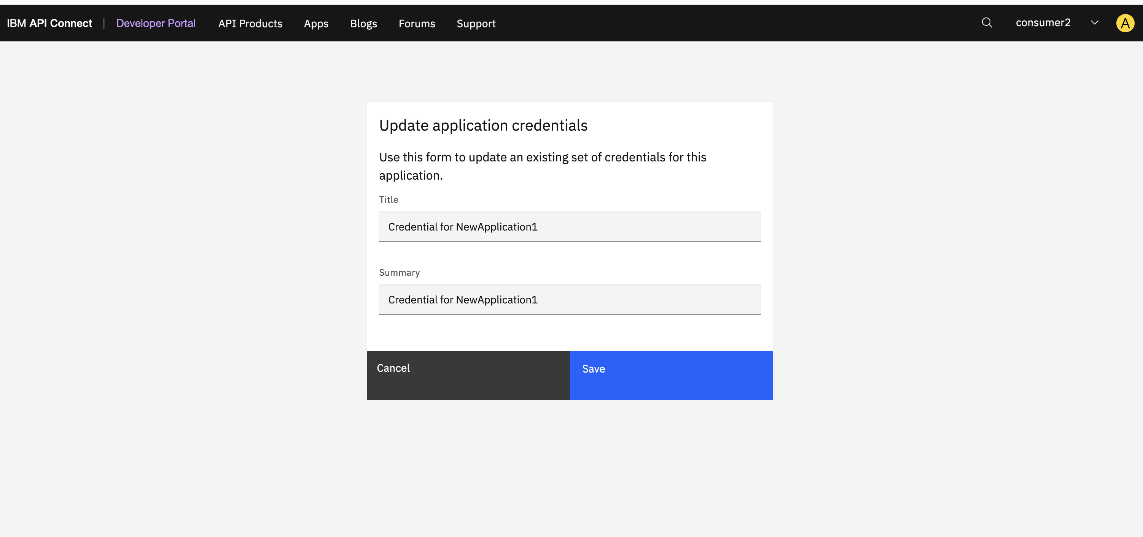
Now add new credential as below and click save
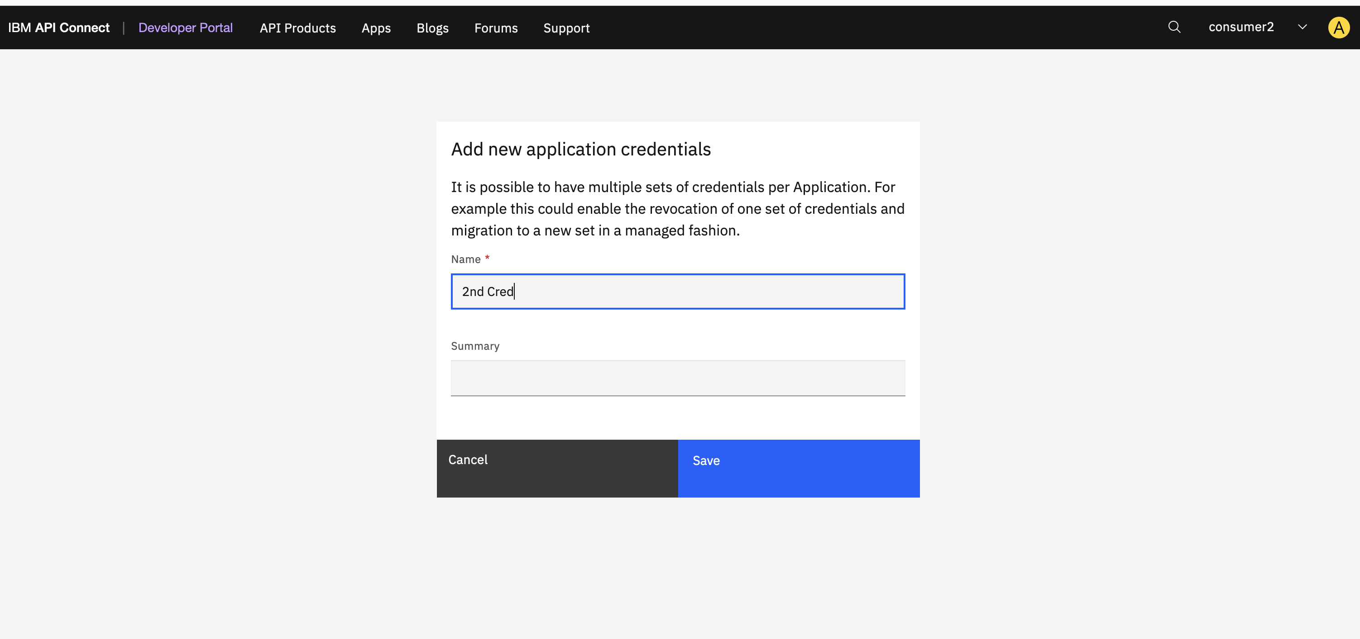
2nd credential created and added as 2nd tab in right of first crednetial, as below
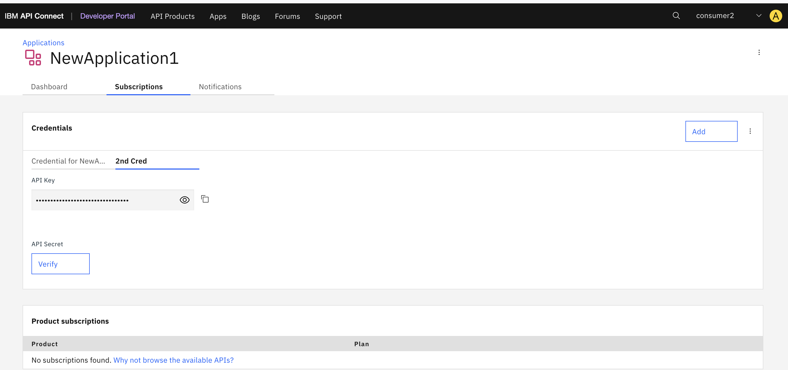

Now I edit the 2nd Cred credential by click 3 dots and edit, then I added summary value and save, you will see the screen as below, now 2nd Cred is refreshed and display as 1st tab. ( Issue : Refresh issue)
