Version installed :
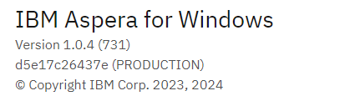
Browser :
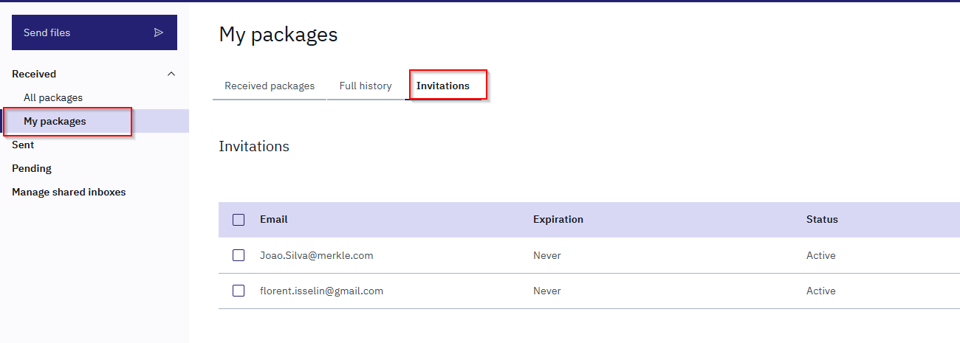

IBM Aspera for Windows
- Invitations is missing
- No access to full history

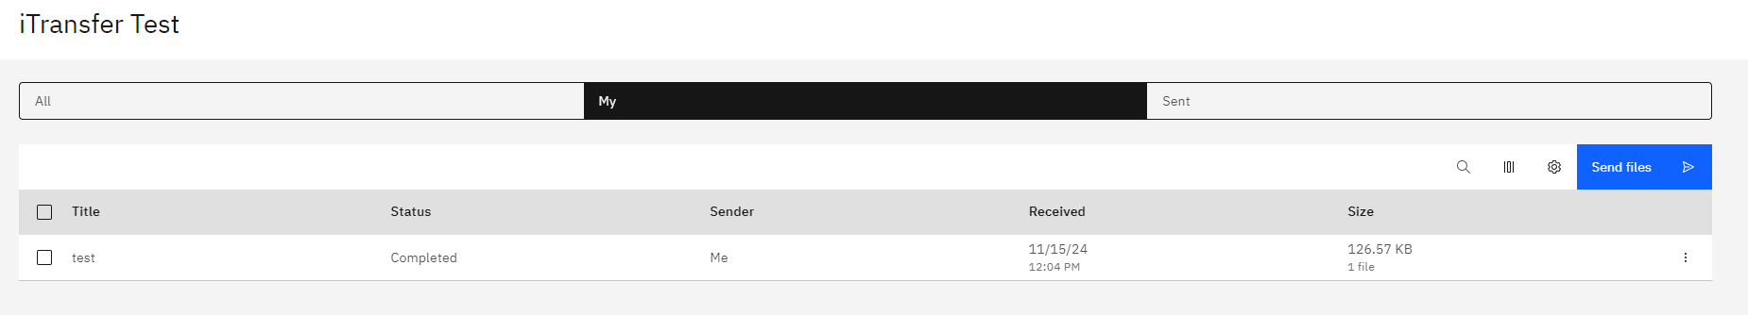

If we have some shared inboxes :

Browser :

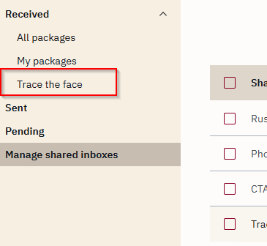

IBM Aspera for Windows
Still just access to All / My / Sent. No a link to see only Shared inbox content
