feature to create a link instead of sending email

Use case 1: Sender creates a public package and sends it to recipient. Sender later decides to share the same package with more recipients.

Use case 2: Sender creates a public package but would like to send it in a separate email as in the example below.

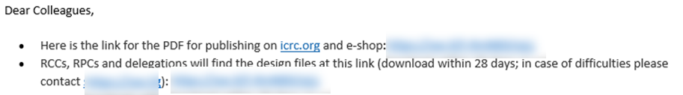

Proposal: allow sender to see & copy the transfer link in the package details of sent files. **Something similar to “Get a link” feature on WeTransfer or google drive**

